National Women's Register Google Ads
What We Changed & What To Watch Next
Prepared 4 August 2026

Quick Read
- The first job has been to get campaigns serving and gathering evidence, not to over-optimise too early.
- We made controlled bid-strategy changes earlier so Google could start generating traffic data.
- On 4 August 2026, Google recommended removing four redundant keywords in the Search - Friendship campaign. I applied that cleanup only.
- I did not apply recommendations that need brand assets, approved ad copy, audience/privacy decisions, or a bigger bidding change.

Why We Have Been Careful
When campaigns have little or no traffic, the useful question is not 'how do we optimise every detail?' yet. The useful question is: can the account serve, gather search-term evidence, and show us what people are actually searching for?
That is why changes have been kept deliberately controlled. Budgets were not increased as part of the recommendation cleanup.

Campaign Overview
This screen is the simplest place to explain the account to someone who does not live in Google Ads. The key things to watch are impressions, clicks, cost, campaign status, and whether a campaign is still in bid-strategy learning.
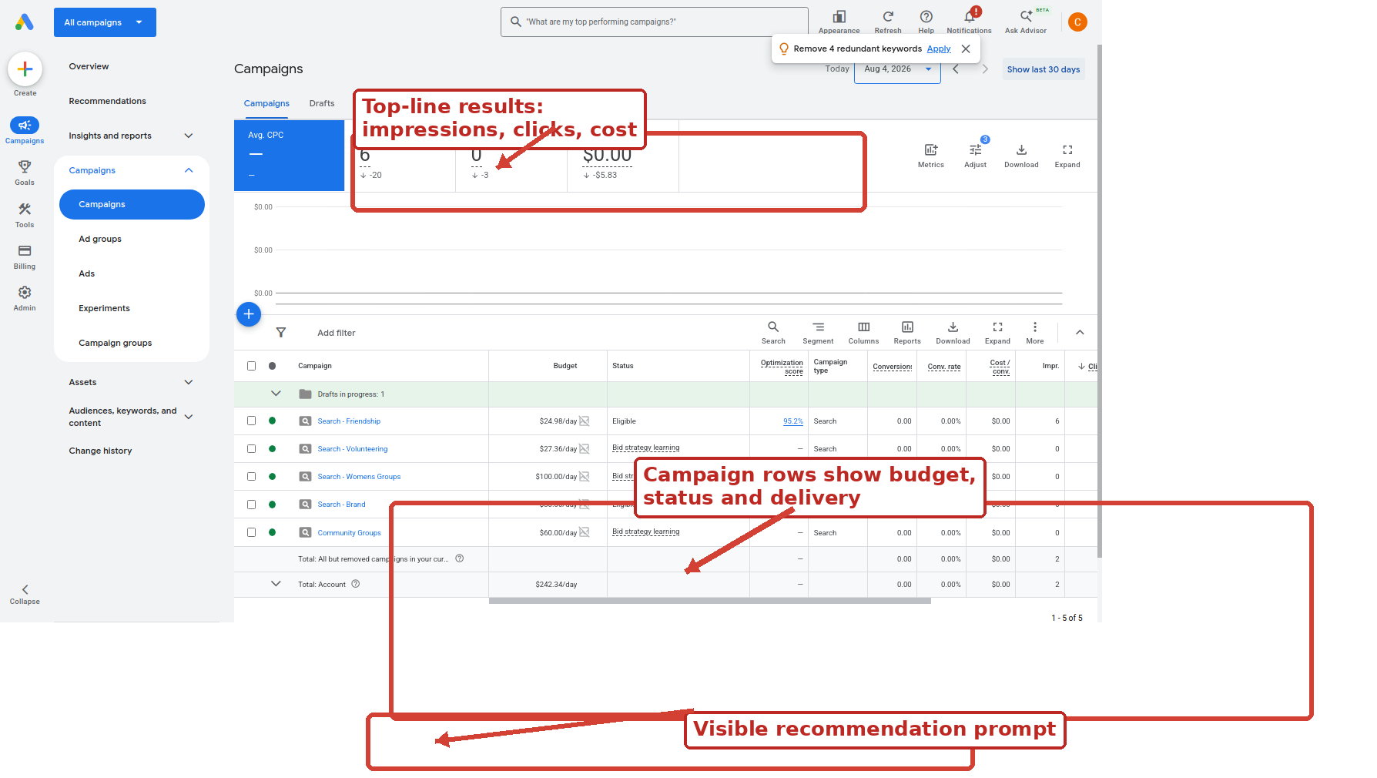
Campaigns view: top-line performance and campaign-level status.

Recommendations Overview
Google Ads recommendations are suggestions, not instructions. Some are helpful, some are premature, and some need human judgement.
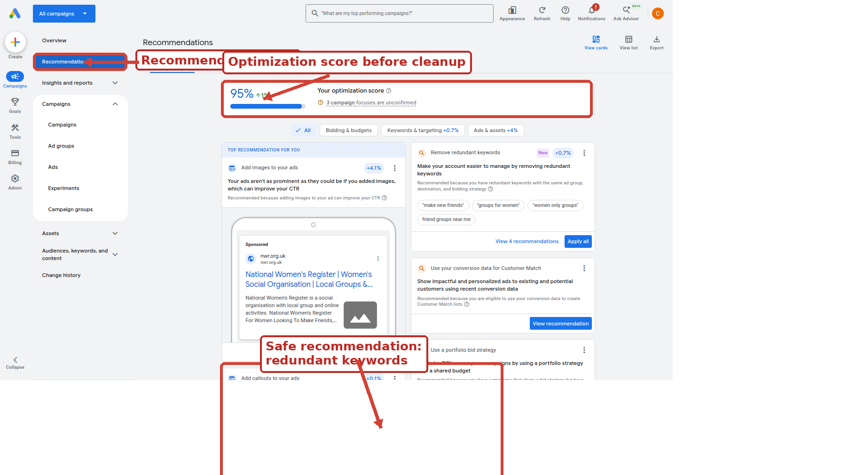
Recommendations page before applying the redundant-keyword cleanup.

Recommendation Applied
The applied recommendation was 'Remove redundant keywords'. Google identified four keyword pairs where one keyword duplicated another inside the same ad group, destination and bidding setup.
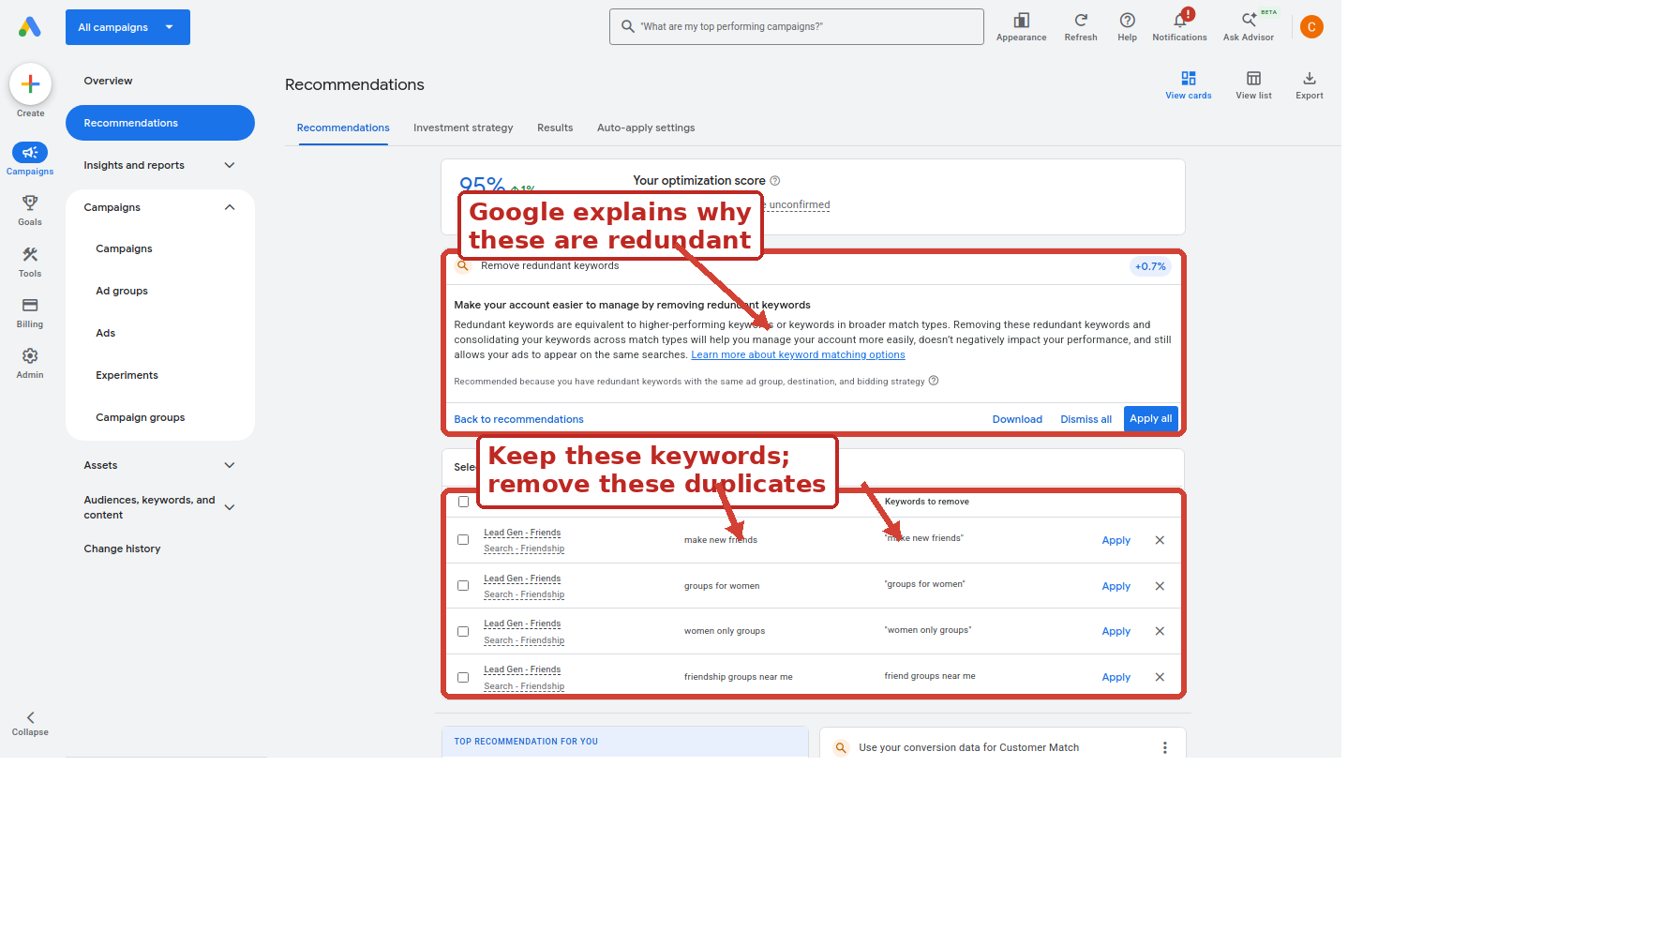
Detail view: the retained keyword and the redundant keyword to remove.

Exactly What Was Removed
- Retained make new friends; removed "make new friends".
- Retained groups for women; removed "groups for women".
- Retained women only groups; removed "women only groups".
- Retained friendship groups near me; removed friend groups near me.

Confirmation
The cleanup was confirmed manually. This was not an 'apply every recommendation' action.
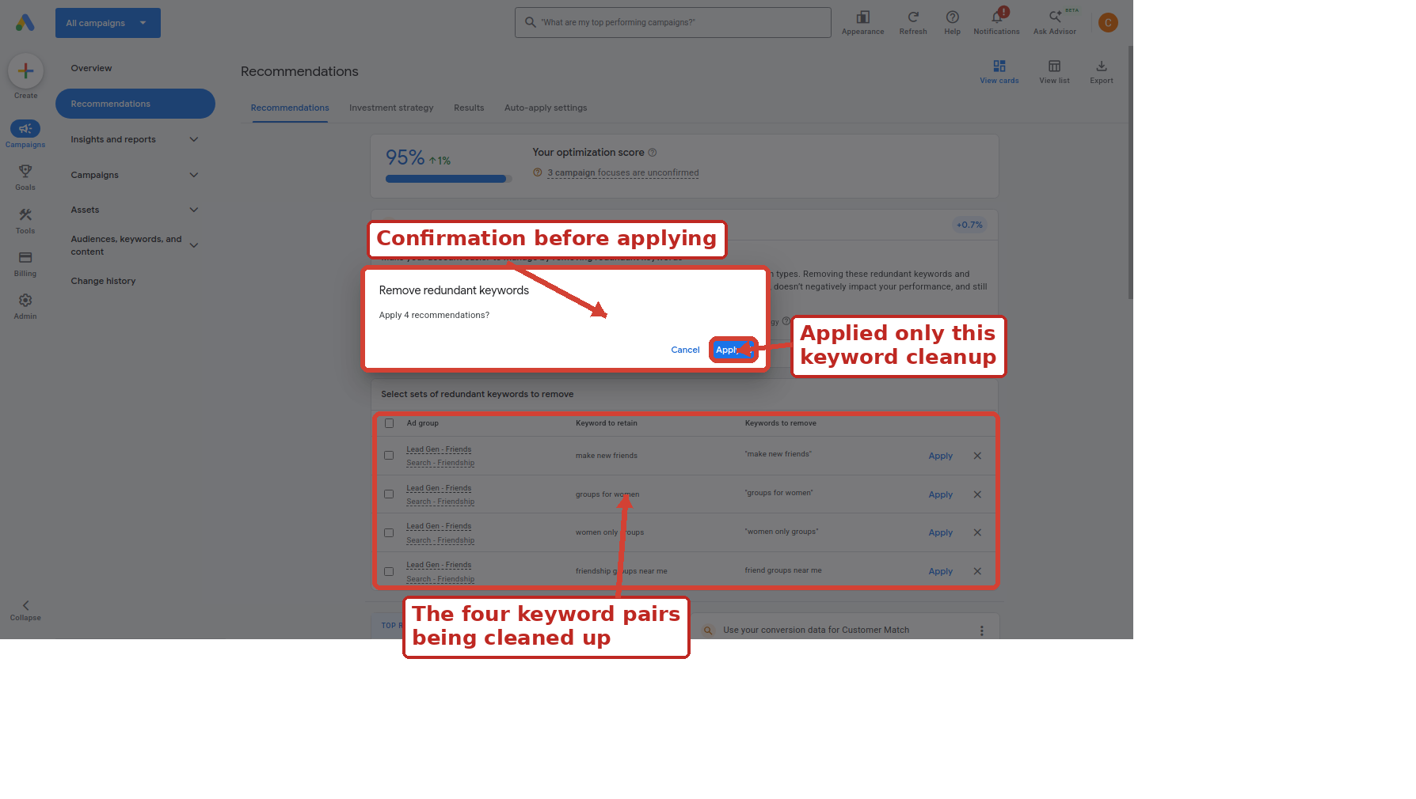
Confirmation modal before applying the four redundant-keyword recommendations.

After The Cleanup
After the redundant-keyword cleanup, the recommendation card disappeared and the optimisation score increased. The remaining recommendations were left alone.
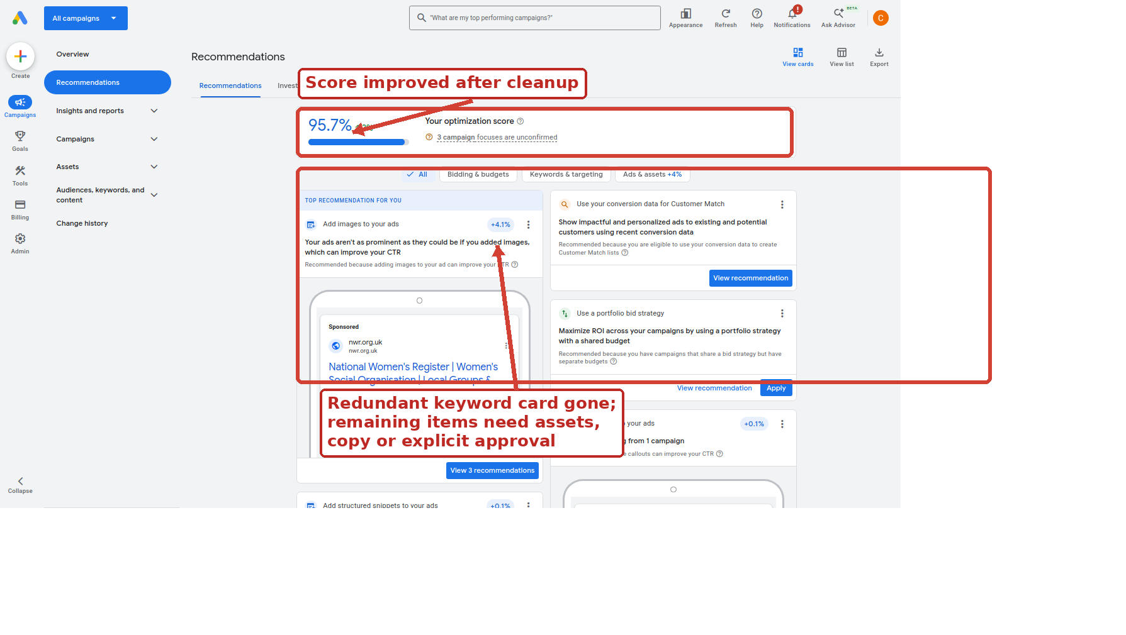
Recommendations page after the redundant-keyword cleanup.

Recommendations Not Applied Yet
- Add images to your ads: potentially useful, but it needs appropriate NWR image assets and brand judgement.
- Use your conversion data for Customer Match: needs explicit audience/privacy strategy before enabling.
- Use a portfolio bid strategy: too large a bidding change while we are still diagnosing delivery.
- Add callouts: needs real NWR-approved callout copy, not placeholder text.
- Add structured snippets: needs real structured snippet content before applying.

What To Watch Next
- Impressions: are the campaigns being shown at all?
- Clicks and CTR: are people engaging with the ads?
- Cost: is spend starting gradually and staying sensible?
- Search terms: are the searches relevant to NWR?
- Conversions: once traffic exists, are clicks turning into useful enquiries or actions?
The next sensible step is continued monitoring. If impressions remain low, inspect eligibility, location targeting, keyword volume and policy limits before making more broad account changes.

